Sicily Inspiration Pack

Magna Graecia
(Latin meaning "Great Greece”)

Sicily, the largest island in the Mediterranean, has a rich and varied history and numerous civilizations have prospered on its soil.
In classical times the Greeks founded colonies in western Sicily and southern Italy, so rich and prosperous that this important geographic region was indicated as the Magna Graecia.
The name that the Greeks gave to Sicily was Trinacria (three points), because of its triangular shape with its three capes.

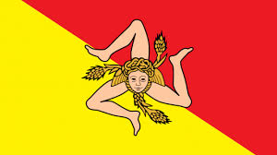

The symbol of the region became the head of Medusa with her three legs bent at the knee. Medusa, as we all know, had snakes instead of hair and her gaze petrified every living being. Its representation in the flag of Sicily (still used) had the meaning of protection of the island against any external enemy.
Sicily is not the only island to have the triskelion (i.e. the representation of a being with three legs) on his coat of arms. In fact there is a triskelion also in the flag of the island of Mann, who has the peculiarity of having a symmetrical shape from whichever side it is observed: Quocunque Jeceris stabit, (i.e. whichever way you throw, it will stand), says its motto, meaning to stress the firmness and strength of character of Manx people.

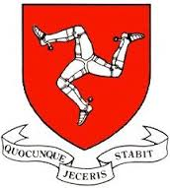

Many scholars believe that the Manx coat of arms is derived directly from the Sicilian triskelion and had arrived in the island at Normans’ time. The Normans as we shall see later conquered almost simultaneously both Sicily and England.

There are many classical myths set in Sicily and in this region countless characters of antiquity, real or imagined had their residence.

Classical Celebrities

Archimedes

One of the most famous inhabitants of Sicily in the classical era was Archimedes, a distinguished mathematician, physicist and inventor, who lived in Syracuse. He is famous for having discovered the laws governing the floating bodies, but they were mostly his war machines to make him a mythical character. Some anecdotes about him have become legendary and one of these is the following.

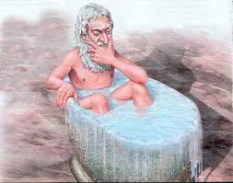

History of King Hiero’s Crown

Hiero, king of Syracuse, decided one day to commission a crown made of solid gold to a skilled craftsman of the city and to this end gave him a pile of gold. When the craftsman gave him the crown, Hiero was very satisfied because it was beautiful and wore it happily. After a few days, however, the rumour spread about that the craftsman had not used all the gold he had been given by the king and had kept a huge part for himself. The beautiful crown was mainly made of silver and only partially of gold. But how do you find out without destroying the beautiful crown? On the other hand Hiero didn’t want to be duped by one of his subjects and more than anything he feared ridicule and loss of power. He decided to turn to Archimedes, who was a close friend and asked him to find a scientific way to solve his doubts.
Archimedes thought to the problem for days and days, until, as he was taking a bath at his house, he found the solution and began to shout across the room: Eureka! Eureka! (Exclamation that has remained popular to this day).
The solution had jumped to his mind because he had realized that his body mass plunging into the water made a certain amount of water get out of the tub. He thought that probably the amount of water coming out of the tub depended on the weight. So he asked Hiero to give him two masses of silver and gold of the same weight of the crown and dipped one at a time in the tub full of water. Meanwhile he collected in a container the water coming out for the gold and the one that went out for silver. Finally he dipped the crown and since the water that came out did not correspond to the amount that was out when he dipped the gold he could deduce precisely that Hiero had indeed been cheated: the crown was made mostly of silver.

Myths

Persephone’s abduction

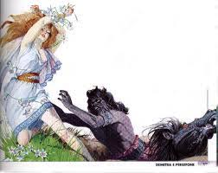

Ceres, the goddess of the harvest, had a beautiful daughter called Persephone (the Spring), who lived in Sicily. One day, the girl had fun at the lake Pergusa in the company of her friends, the nymphs. Pluto, who was in that neighborhood, saw her and it was love at the first sight (at least for him). The gods were very abrupt in those times when they fell in love and so Pluto took the girl and carried her on his shoulders to his kingdom: Hades, the land of the dead. Meanwhile Ceres that no longer had any news of her daughter, wandered disconsolately through the earth and was desperate. Everybody, gods included, denied to know something. Even Zeus, who was aware of everything, kept silent because he didn’t want to annoy his brother Pluto.
Ceres became furious and decided to stop thinking about the earth. So all the leaves fell from the trees and fruits disappeared, there were no more crops to harvest and landscapes became barren and without summers. On the earth fell an eternal winter. At this point, Zeus, who was in danger of losing all humankind at once, had to intervene and not to disappoint neither brother nor sister took a Solomonic decision. Persephone would stay six months with her husband in the realm of the dead and six months on earth with her mother. And so Ceres decided that when Persephone descended into Hades, on earth there would be autumn and winter and when the beautiful goddess reached her mother it would be spring and summer.

The ugliest of all gods: Hephaestus and his forge in Mount Etna

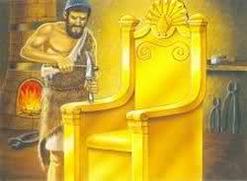

Hephaestus, son of Hera and Zeus, was the ugliest god of Olympus. Such was his ugliness that when his august parents saw him they launched a cry of horror. Hera was so upset that threw him out the window. Hephaestus fell into the Mediterranean Sea, off the coast of Sicily. The poor god, that already was not beautiful, after the fall became lame. Fortunately the Nereids, sea nymphs, had compassion and brought him up. They did well, because the ugly god was exceptionally good in manual tasks: everything he manufactured was of a unique perfection.
Not for nothing he became the god of forges, engineering, sculpture and metallurgy, as well as fire. Hephaestus made his home on Mount Etna, a very good choice considering that he also had his forge there. And how many magnificent works he perfected there! First some superb jewels to express his gratitude to the Nereids, in particular Thetis and Eurynome, who were the ones that had been closer to him. And then the bow and arrows of Apollo and Artemis, gold for Apollo and silver for Artemis, helmet and sandals for Hermes and Helios’ chariot. In short, whenever the gods needed something they turned to him. To do all this work Hephaestus was helped by the Cyclops and he also built some automatons of metal to assist in his more delicate works. He also built Talos, the automaton giant that protected Crete.
Do not think however that Hephaestus had forgotten the wrong he had suffered from his immortal parent when he was a baby. When he had enough experience and reputation as a genius builder he created a beautiful gold throne and sent it to his mother. Hera welcomed the beautiful gift judging it truly worthy of her, but when she sat on it she remained prisoner and was unable to free herself. The other gods begged Hephaestus for days to come and free his mother, but he refused. Eventually Dionysus made him drunk and took him back to Mount Olympus on the back of a donkey.
Only then Hephaestus agreed to free his mother, but on one condition. He, the ugliest of the gods, demanded to have the most beautiful of the goddesses for wife: Aphrodite. The goddess of love was forced to accept the marriage proposal and went to live with Hephaestus on Mount Etna. Then Hephaestus gave her a beautiful gift: a solid gold girdle beautifully carved and inlaid with precious stones. Moreover this was a magic girdle, because whenever Aphrodite wore it she was able to get whatever she wanted from everybody, including Zeus!
In addition to the gods also a handful of very lucky humans had weapons built by Hephaestus. But only those who could claim a direct lineage to some god or goddess. Hephaestus manufactured the beautiful arms of Achilles, son of Thetis. And Aphrodite herself asked him to make the armor and the helmet of Aeneas, her favorite hero.

Scylla and Charybdis

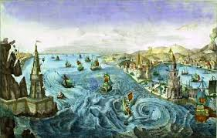

Scylla and Charybdis were two terrible creatures that inhabited the opposite shores of the Strait of Messina. In this stretch of sea the sea currents create vortices that in ancient times were attributed to the existence of the two monsters. Yet Scylla had not always been a terrible and monstrous creature. At one time she was a beautiful and graceful nymph who had had the misfortune to be loved by Glaucus, a creature half man, half fish. But when Glaucus had declared his love, Scilla shocked at the sight of him had fled and went hiding in the mountains. Then Glaucus decided to seduce her by demanding a love potion to the famous sorceress Circe. It was a fatal mistake. The sorceress was deeply in love with Glauco, and not only she did not give him the love potion, but actually prepared a uglyfying potion for Scylla.
And so just before the nymph bathed in the shores of Zancle, the old Messina, Circe emptied the contents of a vial in the water. When poor Scilla dived in, monstrous legs began to sprout next to her legs and finally her own legs took this aspect. The beautiful girl who had enchanted gods and demigods was now transformed into a hideous monster. Ashamed Scylla took refuge in a cave over the Strait of Messina, just in front of Charybdis. And since then she strips away the sailors from ships that pass in front of her den.
Charybdis instead, had always been kind of monstrous and her appetite had always been scary. Not in the sense that she was a healthy girl from robust appetite, but rather that her voracity was really frightening. One day she had even devoured in a flash some oxen of Hiero’s herd, while Heracles was taking them to pasture. Zeus became so infuriated that he turned her into a horrifying monster. Since then Charybdis, whose insatiable hunger had even worsened once she became a monster, swallows the seawater three times a day and three times she spits it, creating vortices that sink passing ships.
But if by chance you pass by the Strait of Messina do not be afraid, it is true that there are currents, but definitely bearable and not as dangerous as these myths wanted us to believe!

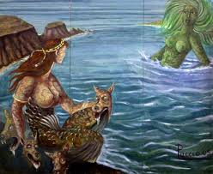

The legends of the Arab period: the “truvature” (findings)

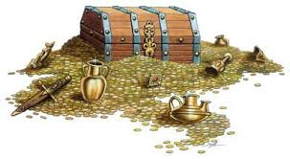

When Sicily was conquered by the Arabs began for the island a period of great prosperity when arts and commerce flourished and people were very wealthy. Very wisely the Arabs guaranteed a certain religious tolerance and allowed everyone to freely practice their faith, even though non-Muslims were required to pay a fee, the gezia.
Before reaching this happy balance, however, Christians were persecuted and of course deprived of all the wealth on which Muslims could lay their hands on. Which is why Christians obviously began to hide their treasures in unexpected places waiting for better times. And to protect this wealth, lacking of today's alarms and security systems, they engaged the local goblins, the pircanti.
Apparently Sicily is full of treasures hidden underground, called truvature. But the real challenge is not just to find them, but to reverse the protective spells.
In Acireale, near the Chiesa della Grazia (Church of Grace), there is a fabulous treasure, but to take it home one must perform a complicated procedure and indeed also a bit disgusting: you have to eat a raw sarpa (a type of local fish) and drink 10 liters of wine.
Near Etna is an enchanted cave, known as the Female and the shoemaker’s cave, because the souls of these two victims, have now become pircanti and are doomed to protect the enormous fortune therein stored. The treasure - which consists of twenty-four beautiful piles of gold coins, as many as were the brigands who had accumulated them - would be relatively easy to find. One has just to open the large square stone that closes the entrance of the cave. The problem is that once inside the two pircanti make impossible for everybody taking away even a small piece of gold!

The Vikings in Sicily

The Devils of Zisa’s Legend

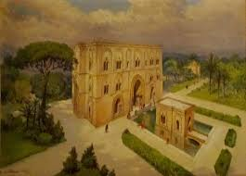

When during the eleventh century the Muslims were expelled from Sicily, the situation was reversed and it was the Muslims who buried huge treasures in the island. Their treasures, however, according to the Sicilians, were usually not guarded by pircanti, but by devils.
A very famous treasure is hidden in the castle of Zisa.
Zisa is a palace of square shape surrounded by a garden, which at the time of the Normans was beautiful and lush. Despite the hot and sultry summers the inhabitants of the building never suffered the heat because its structure had been constructed so as to create air currents that would make the palace cool even in summer. When the south wind blew, huge canvases soaked in water were hung on the walls that functioned as an ecologically and environmentally friendly air-conditioner.
King William II liked to spend all his free time at Zisa and preferred this residence to the city palace. To the great scandal of the church he loved dressing in the Arab fashion and was said to possess even a discreet harem full of beautiful girls. To get right with his conscience of a Catholic man, however, he had built in this palace a chapel dedicated to the Holy Trinity.

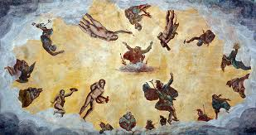

If by chance you are passing near Zisa on March the 25th, Feast of the Annunciation, you will see the devils painted on one of its walls move their tail and grimace and as much as you try you won’t be able to count them. This is because the devils guard a treasure consisting of a huge amount of gold coins, so many that they cannot be counted. The money is "enchanted" and the devils are absolutely determined to make sure it doesn’t fall into the hands of the good Christians. But popular sources assert that the system to be in possession of the treasure does exist: you have just to find it.

Anglo-Sicilian Legends

Around the year one thousand two islands in the north and south of Europe were conquered by the Normans. One was England and the other Sicily. From that moment the cultural exchanges between the two islands became very intense, many Sicilians went to England, many English went to Sicily to perfect their studies, and this island became the adopted home of two important characters: King Arthur and his sister Morgan Le Fay. According to the legend below it seems that Morgan Le Fay had also offered her help for the conquest of Sicily when it was still in the hands of the Muslims ...

Morgan Le Fay

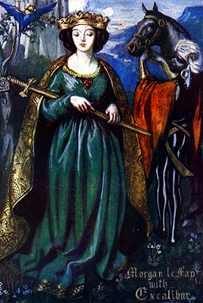

Legend has it that one day many many years ago, a strong brave man from the North (a Norman) arrived in Calabria and sat on the shore of the sea. Immediately he felt an intoxicating smell of flowers, the music of war dances and heartbreaking cries of men and women.
"Where do these scents and these sounds come from?" He asked to a local resident.

"Alas, my lord," was the answer "The perfume is that of orange blossoms and jasmine, the dances are those of the Muslim warriors and the cries those of the Christians subjugated. They are the sounds and smells of the beautiful island called Sicily. "
Then Roger, that was the name of the brave warrior, ardently wished to conquer the island, but he had no ships. He began to despair when from the sea it appeared a beautiful woman, who was driving a chariot drawn by horses. It was Morgan Le Fay, King Arthur’s sister.
"Get on my coach Roger. I'll take you to Sicily. "
"Never!" Said Roger fervently "It’s not your magic arts that will give me Sicily! I will conquer this island with my means! "
The fairy then threw three stones in the sea and Sicily appeared even closer and desirable, only a few meters distant.
"Get on board" invited him once again Morgan smiling "Come with me on my chariot."
"Never," Roger repeated with determination "If I will receive help, it will not be that of a fairy. Jesus and the Virgin Mary will help me conquer Sicily. "
At the name of Jesus and the Virgin Mary the fairy disappeared in the sea, along with the chariot and all the horses and in front of the king appeared a fleet of ships, ready to make war with the Muslims.

King Arthur

When King Arthur knew his end was approaching he prayed heaven to fulfill his last wish, to repair his precious sword which was broken in two parts. Immediately angels lifted him into the air and carried him on Mount Etna, where the fire immediately welded the two sections of his sword. It was spring and Sicily was all in bloom. The view that appeared to the eyes of the good king was so beautiful and moving that Arthur begged God not to let him die and allow him to remain in Sicily.
His prayer was answered and indeed God gave him a beautiful palace and the horse of the bishop of Catania. Truth be told without telling the bishop, who made his guards look for his horse for days, until a servant who had followed the horse’s traces to Mount Etna saw a beautiful garden, a majestic palace and King Arthur riding the bishop’s horse (and obviously he did not dare tell him anything).

The legend says that the presence of King Arthur on Mount Etna has become crucial for the security of the Sicilians. In case of eruption the good king has just to put his magic sword in the ground to make the lava stop immediately. Unfortunately, sometimes the king is out of home - this happens when he returns to his homeland to bring the good Sicilian fruits to the English children - and then, unfortunately, no one protects Sicily and lava can act undisturbed.

Tipical Sicilian and Sicilian-Bulgarian Characters...

Colapesce

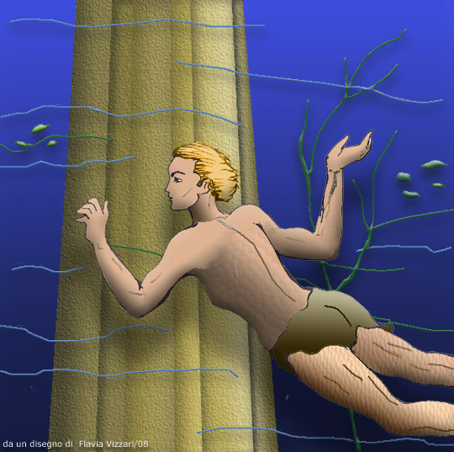

Colapesce is the national legend of Sicily.
Once upon a time lived in Messina a boy named Nicola who had a passion for the sea. Nicola spent all his time to swim, fish or just play with water. His mother, however, would have liked that his only son would help her in the shop, especially as she was a widow. Nicola, however, didn’t want to live that life and day after day he went to sea.
One day his mother exasperated for the umpteenth refusal of her son, threw him a curse: "since you like the sea so much, I wish you can become like a fish!" The curse had immediate effect and Nicola got his gills and his legs became covered with scales. Then people began calling him Colapesce (Colafish).
One day in Messina arrived King Frederick, who had heard about the amazing undertakings performed by Colapesce and wanted to see with his own eyes what this man-fish was capable of doing. He threw a cup into the sea and asked Colapesce to go and fish it out and to report what he had seen under water. The boy came back almost immediately with the cup in his hand and told of huge fish, scary monsters and gigantic caves and also added that he had discovered that Sicily rested on three pillars. The king, however, was not satisfied and wanted to launch another challenge to the young. He then threw into the sea a ring studded with precious stones.

The crowd fell silent because the undertaking seemed even superior to the forces of an exceptional underwater swimmer as Colapesce. The ring was not as large and visible as the cup and Colapesce tried to find it for hours getting closer and closer to the columns. He had no problem breathing because the gills worked perfectly, like a real fish. He then inspected the first column and saw that it was perfectly intact, but there was no trace of the ring. Then he swam toward the second column that actually was a little worn, but still held good. The ring was not there. Finally he advanced to the third column and found it right there. But what a disaster appeared before his eyes!
The column was broken in two and was going to collapse, then the whole Sicily would have collapsed. The young man meditated for a few seconds. To return to the surface with the jewel and prove to that stupid king what was Colapesce capable of? Or to sacrifice himself for his beloved land? Colapesce had no doubts, left the ring and began to hold up the column and never returned to the surface. Some people say, however, that in the summer evenings, when you walk on the shore near Messina sometimes you can hear a voice coming from the sea whispering: "Help me! I cannot take it anymore!"

Giufà

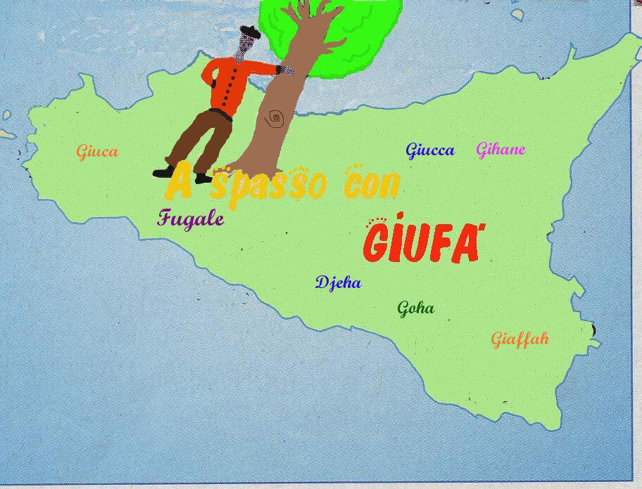

Giufà, naive but shrewd countryman, honest and dishonest at the same time, with a kind of surreal wisdom that manifests itself almost against his will, is a typical character of the Sicilian folklore. This character, however, was not born on this island but came very likely with the Muslims. It is closely related to the Arabic Juha, the turkish Nasreddin Hoca and the Bulgarian Nastradin Hodja. It seems that a Nasr Eddin Hodja lived in Turkey from 1208 to 1284 and that in some mysterious way his life and his adventures have merged with the already existing character of the Arab Juha.
A storyteller described him in this way: Juha can be considered in two ways, or he is so intelligent that he has become stupid, or he is so stupid that he ends up saying something intelligent. And this description fits perfectly for both the Sicilian Giufà and the Bulgarian Nastradin Hodja.

Below one of Giufà’s stories, which by the way is almost the same of one of Nastradin Hodja’s stories (where there is a jar instead of the pot).
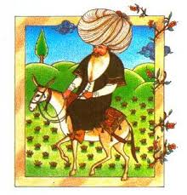

Giufà and the borrowed pot

Giufà, who seemed so silly, but silly he wasn’t, had a neighbor who believed to be very clever. Of him it was said that he always borrowed things and never returned them. So Giufà decided to teach him a lesson. One day he asked to borrow a big pot to cook the soup. After a while he returned it to the neighbor, who surprised but happy to see a little pot inside the big one asked him what had happened. "Your pot was pregnant and gave birth to a little pot," said Giufà.
The neighbor went away quite satisfied thinking that cheating Giufà was incredibly easy.
After a while Giufà asked again to borrow the pot and the neighbor was happy to give it to him believing he would make some other advantage. But time passed and the pot did not return. So the neighbor decided to go and ask himself. Giufà opened the door. He looked sad and sorrowful and told him: "I'm sorry, but as she was cooking a bean soup your pot felt ill, so badly ill that she died."
The neighbor did not like that answer at all and said that Giufà told a lot of nonsense and that he had never heard that a pot was dead.
"Really?" Said Giufà. "If a pot is able to give birth it will also be able to die." He slammed the door on the neighbor and kept the big pot instead of the little one.

Some information about Sicily and Palermo

Books to read
The Leopard, Giuseppe Tomasi di Lampedusa (story of a noble family and of changes in Sicilian life and society during the Risorgimento)
A month with Montalbano, by Andrea Camilleri
The Day of the Owl, Leonardo Sciascia (on mafia in Sicily)
Short stories for a year, Pirandello.

Monuments to visit
Palazzo dei Normanni and Cappella palatina (Palace of the Normans and Palace Chapel)
The cattedrale
Piazza Pretoria (called place of shame because of the naked statues which adorn it)
Palazzo Abatellis (for its famous fresco “Death’s triumph” )
Chiesa di San Francesco e l’antica focacceria (a storical tavern from the 19th century)
The Zisa, Arab style palace
Duomo of Monreale. Attention! A popular saying affirms that: “whoever goes to Palermo but don’t go to Monreale, starts his journey as a donkey and comes back as a pig!”

Foods to eat
pane con panelle (roll with panelle, a kind of chickpeas fritters)
pane con la milza (roll with spleen, for brave people)
involtini di carne (beef rolls with raisins and pinenuts)
involtini di pesce spada (swordfish rolls)
sarde a beccafico (Sicilian stuffed sardines)
pasta con le sarde e il finocchietto selvatico (pasta with sardines, wild fennel, raisins, saffron and pine nuts)
pasta con le sarde a mare (esemple of Sicilian humor; as the above but without sardines, that stayed in the sea)
caponata di melenzane (aubergine stew with capers, olives and tomatoes
cannolo e cassata (Sicilian desserts with ricotta)
brioscia con gelato (brioche with icecream)

A few useful words of Italian
yes: si
no: no
thank you: grazie
you welcome: prego
please: per favore
meat: carne
veal: vitello
lamb: agnello
chicken: pollo
fish: pesce
milk: latte
cheese: formaggio
bread: pane
butter: bread
salad: insalata

Good morning: buon giorno
Good evening: buona sera
How much is it? Quanto costa…?

“This project has been funded with support from the European Commission. This publication reflects the views only of the author, and the Commission cannot be held responsible for any use which may be made of the information contained therein.”

